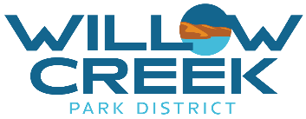

Public Records Request
Submit this completed request to Katie Murray, administrative Manager, by mail at PO BOX 582, Heppner, OR 97836 or by email at kmurray@wcparkdistrict.org. Please fill out each field in the form below to request public records from Willow Creek Park District. You will receive a receipt of submittal by email when your request is received.

Requester Name: _________________________________ Date of Request: ______________________

Organization Name
(if applicable):

Mailing Address:
City | State | ZIP Code

Phone: Email

Provide a detailed description of the documents you are requesting:

I request that the documents be provided in the following format:
I wish to arrange an opportunity to personally inspect the requested records. I wish to receive a hard (paper) copy of the requested records.
I would like to have these records provided to me an electronic format.

Signature: Date:

Your signature indicates that you understand that Willow Creek Park District will respond to your request by email as soon as practicable. You understand that there may be costs related to this request based on the fee structure adopted by the District, and you are aware that you will be notified by staff if any fees need to be paid in order to complete your request.

